Art Direction Concept Document

Philosophy of this particular Art Direction:

* The **Characters are the stars of the show** (the player character, NPCs, enemies, wildlife and random extras).
* **Characters behave in odd ways**, say odd things and are constantly making the player laugh at their absurdity.
* Because the characters are the stars, **the environment should be a backdrop** (or stage) for the characters to perform.
* The overall vibe of the world should say **“oppressed Medieval with a hint of hope”** as opposed to “Life is Good”. I think “times are tough” is a humour starting point to build from.
* The overall tone of the art should be light (ie. day time, real world as opposed to demonic or apocalyptic).
* Absurdity of circumstances should be exaggerated wherever possible in the characters, world, etc. The idea is to be humorous (if possible, clever and subtle). For example:
  + Rundown houses should be *really* run down (perhaps just one wall with a door, no roof or other walls.
  + Entire families living in a small barn with the pigs and chickens
  + Knights cannot afford horses so they use coconuts to make horse sounds.
  + A peasant is a normal, dirty peasant but holds a pitchfork which is simply a stick with a table fork strapped to it (because he can’t afford a proper pitchfork).
  + A bridge has a cardboard cutout of a troll underneath it with a “back in 15 minutes” sign next to it.

## Summary of Art Direction

This level of detail (if possible), camera, lighting, BUT with a more lived-in world (things are more run-down, people’s clothes are dirty, tents need repair, pigs living in the fountain, etc)...

|  |  |
| --- | --- |
|  |  |

With these sorts of character outfits, colours, sigils, armour…

|  |  |  |
| --- | --- | --- |
|  |  |  |

In these settings / locations…

|  |  |
| --- | --- |
|  |  |

With these kind of punchy particle effects…

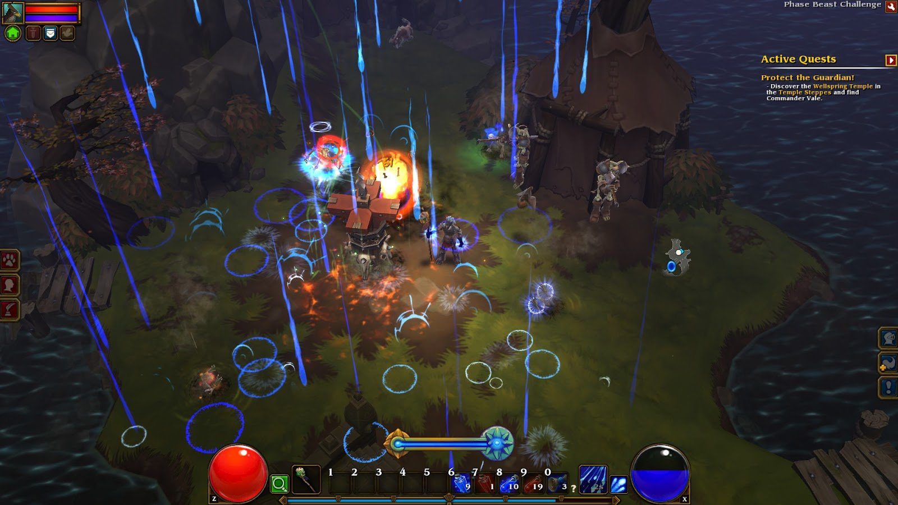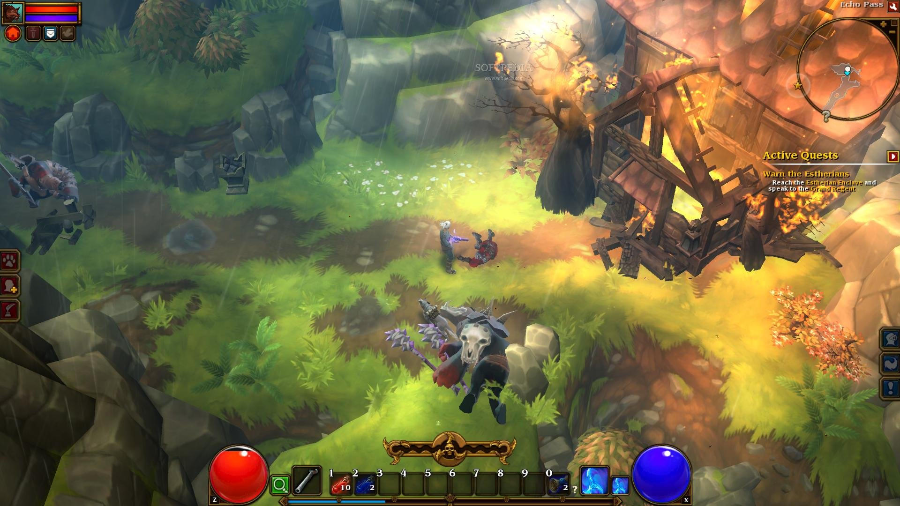

With a softer, 1970s-like instagram filter as our guide for colour, saturation, post-processing:

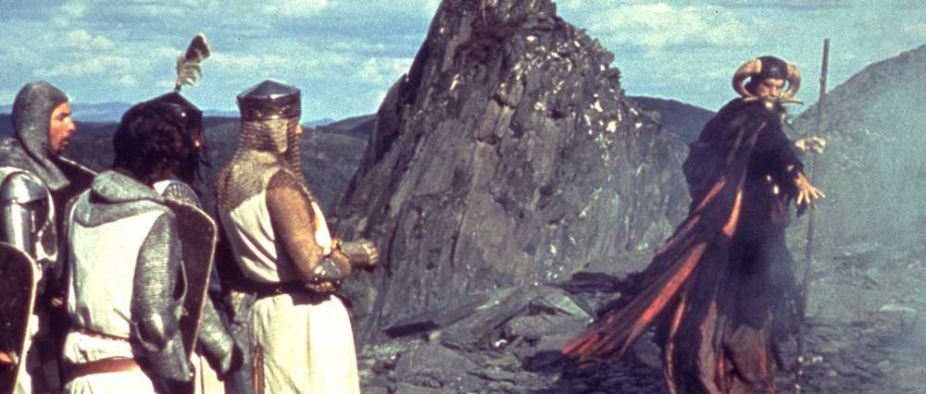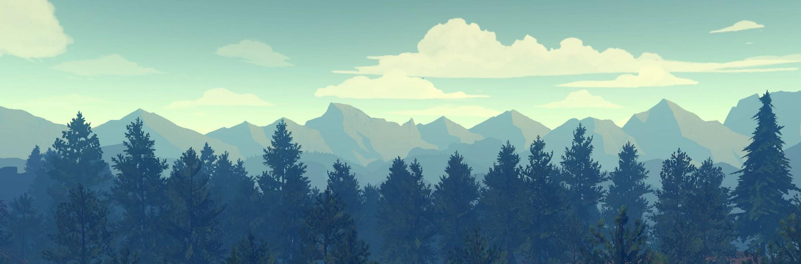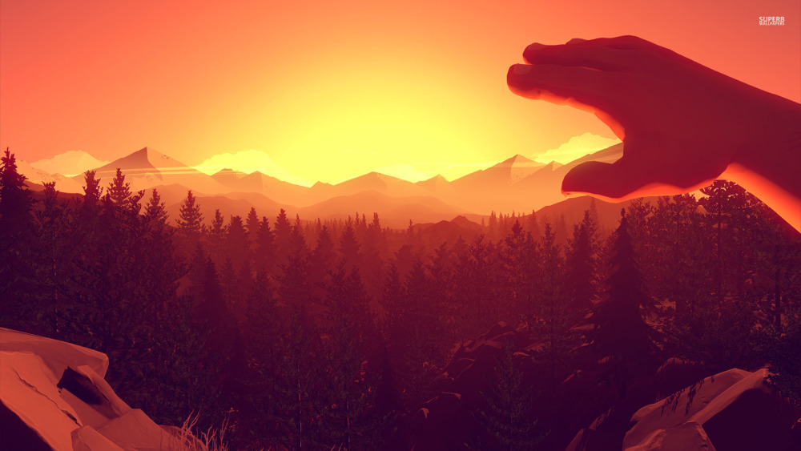

# More Detailed Explanation

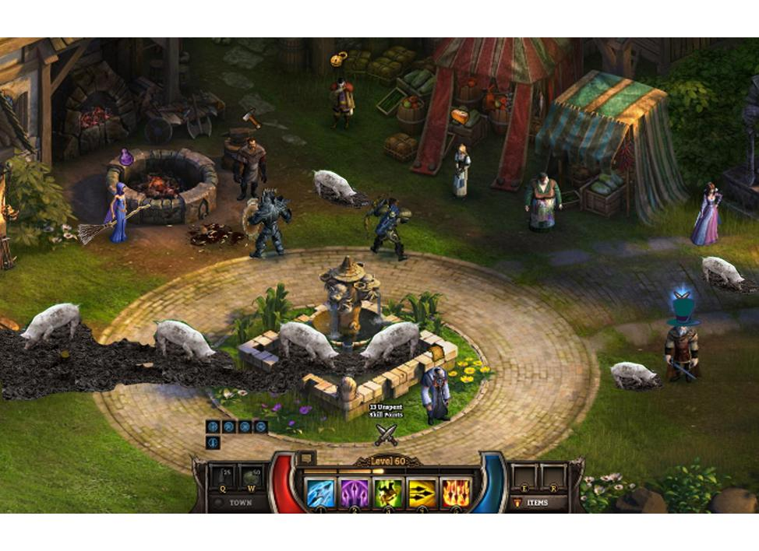

I like the perspective, NPC density and level of detail of this image. I would vote for our world being a lot more “lived in” and less pristine. Also funny. For example, the pigs have overtaken this pretty fountain and made it their own (my own visual addition). The stalls up the back would have holes that have been patched over, leaky roofs, etc. The townsfolk would look like they’ve been working hard, not like they’ve come straight from the salon as they do in this image. I like that the characters pop against the background (they tend to be brighter).

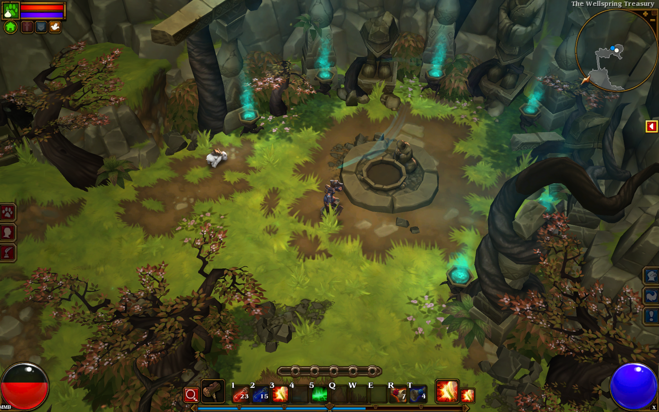

I like the balance of light and dark in these following few images from Torchlight 2. The grass is green and alive (making the world feel light and fresh) but the overall lighting is darker giving mood. There is plenty of mud. The game also uses rain, particles, torches, etc well. This particular image has nice green grass, alive trees, but twisted and with personality.



Cool particle effect, although the overall lighting in this image is too dark.



Fire is used to create pockets of light. Also, the level design of torchlight 2 is really great - nice use of foreground and background elements.

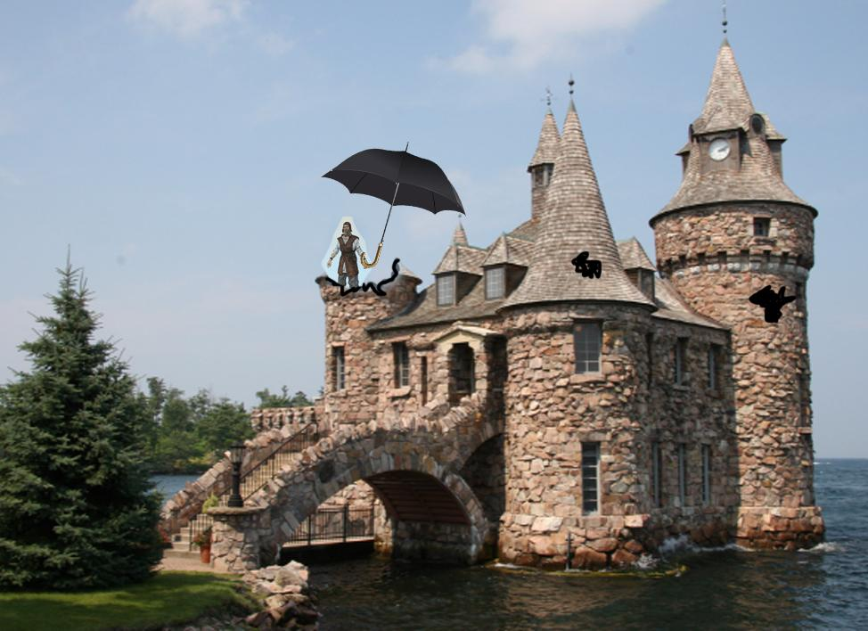

I like the stonework, water, bridge and petit size of this castle. If we had this with some of the roof missing, but covered over with something funny (perhaps one of the castle staff members is standing holding an umbrella to stop water going in… the player would speak to this peasant to get into the castle).

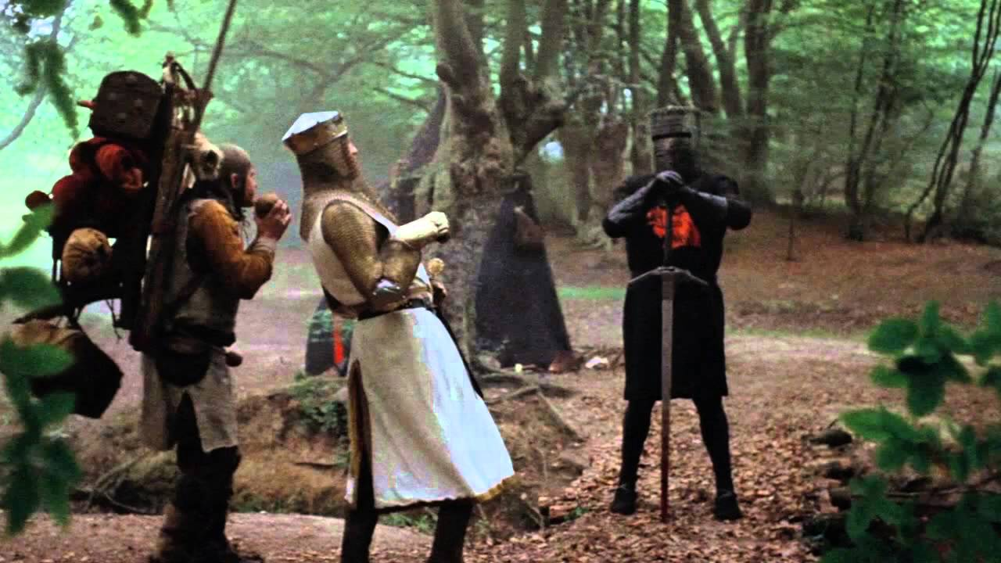

Although not a game image, I like many things in this direction.

* The setting with leaf-covered ground and backdrop of forest
* The splash of colour on the black knight
* The ridiculousness of a knight and his servant pretending to be riding a horse

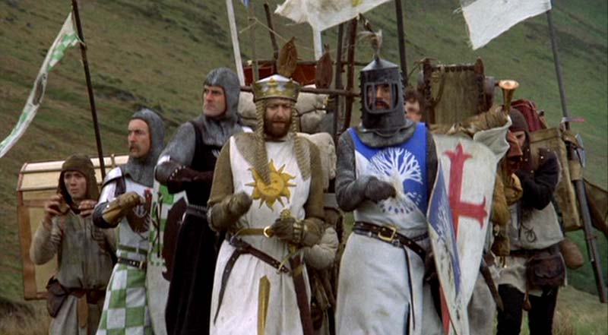

Likewise, not a game screen but I like the way the characters punch out from the drab background with their bright and interesting outfits. The two leading characters have someone ridiculous headgear (the flopsy chain mail on the king and the peak-to-look-out grill on the knight). The colours are fairly traditional (green checkered, gold, blue, red cross) but the sigils are comedic (the chicken for “brave” Sir Robin, the sun-god for Arthur, etc).

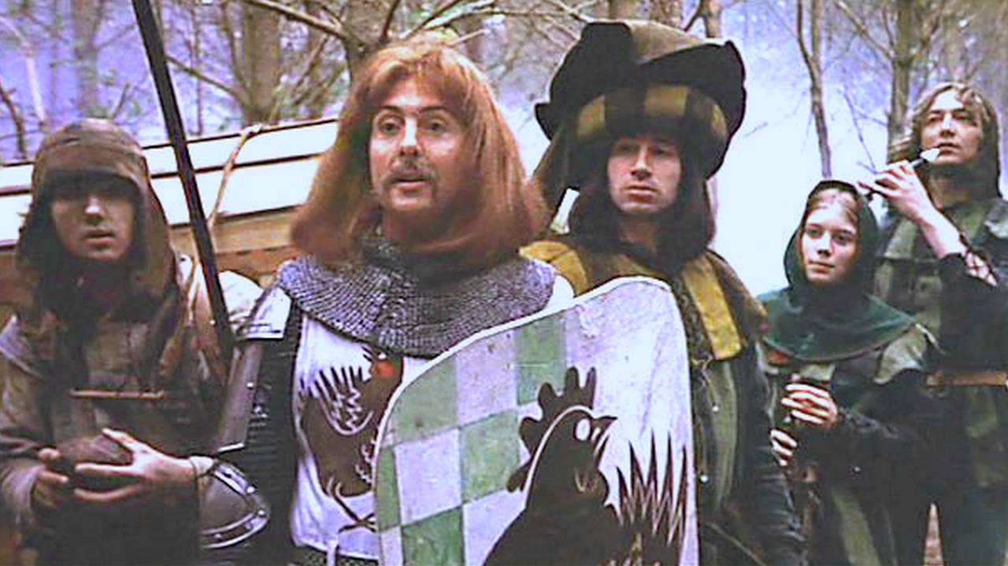

The flopsy hair of Sir Robin and the oversized hat of the minstrel. Also the implied “mysterious gloom” behind them from time to time to indicate that this world is trying hard to convince you that its spooky.

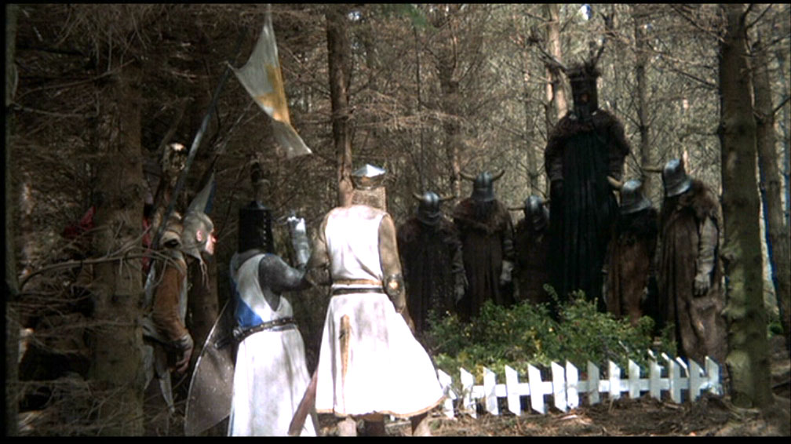

Some oversized enemies would be good. I like the overall idea of knights stereotypical warrior looks - knights of the round table, vikings, french soliders, etc.



Cool wizard. I like the black and red robes and non-traditional horns.

Generally with all of the Monty Python images I really like the “Instagram 1970’s filter” look to them. I think this old school feel could be a really novel look if we can pull it off, differentiating from many games that looks modern and digital.

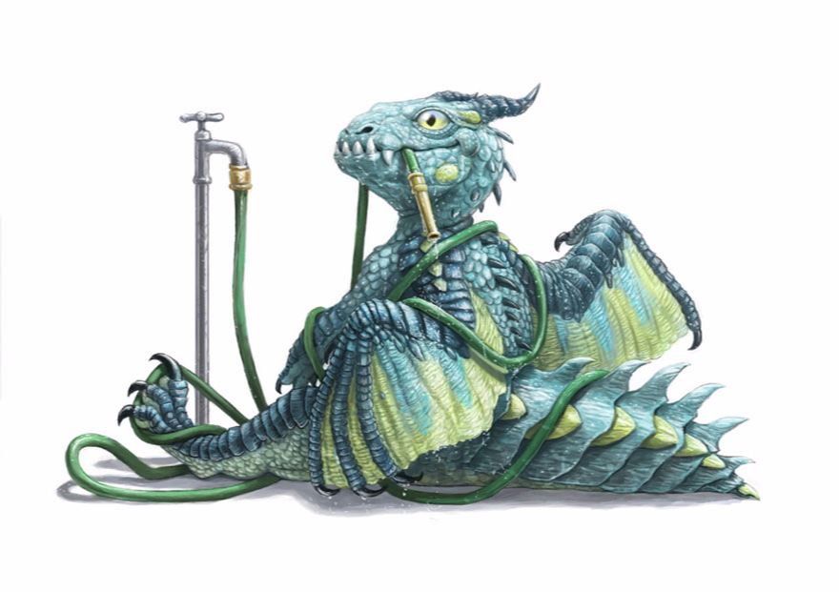

This is less about art direction and more about humour direction. Something about this dragon is funny - like a cross between a puppy and a teenager.

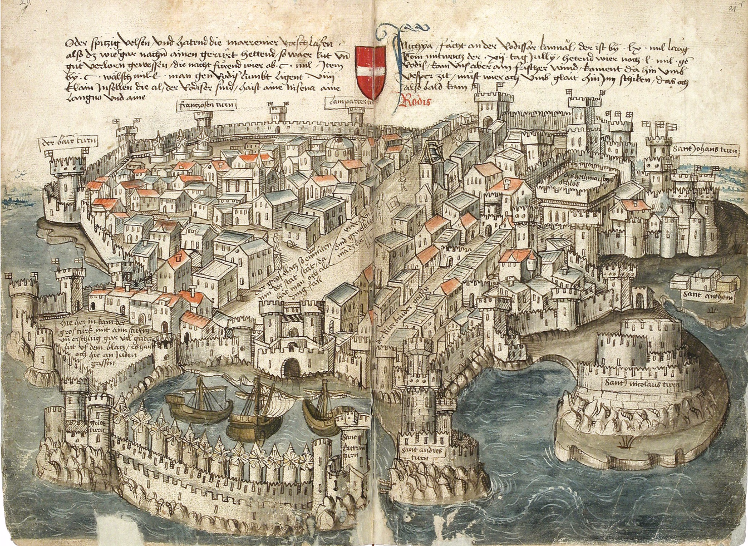

I like this alot as a potential art style for a meta map (world map) with its incorrect perspective that represents how people represented the world back in the day.



I like this softer palette - kinda speaks to the 1970s instagram filter I like.

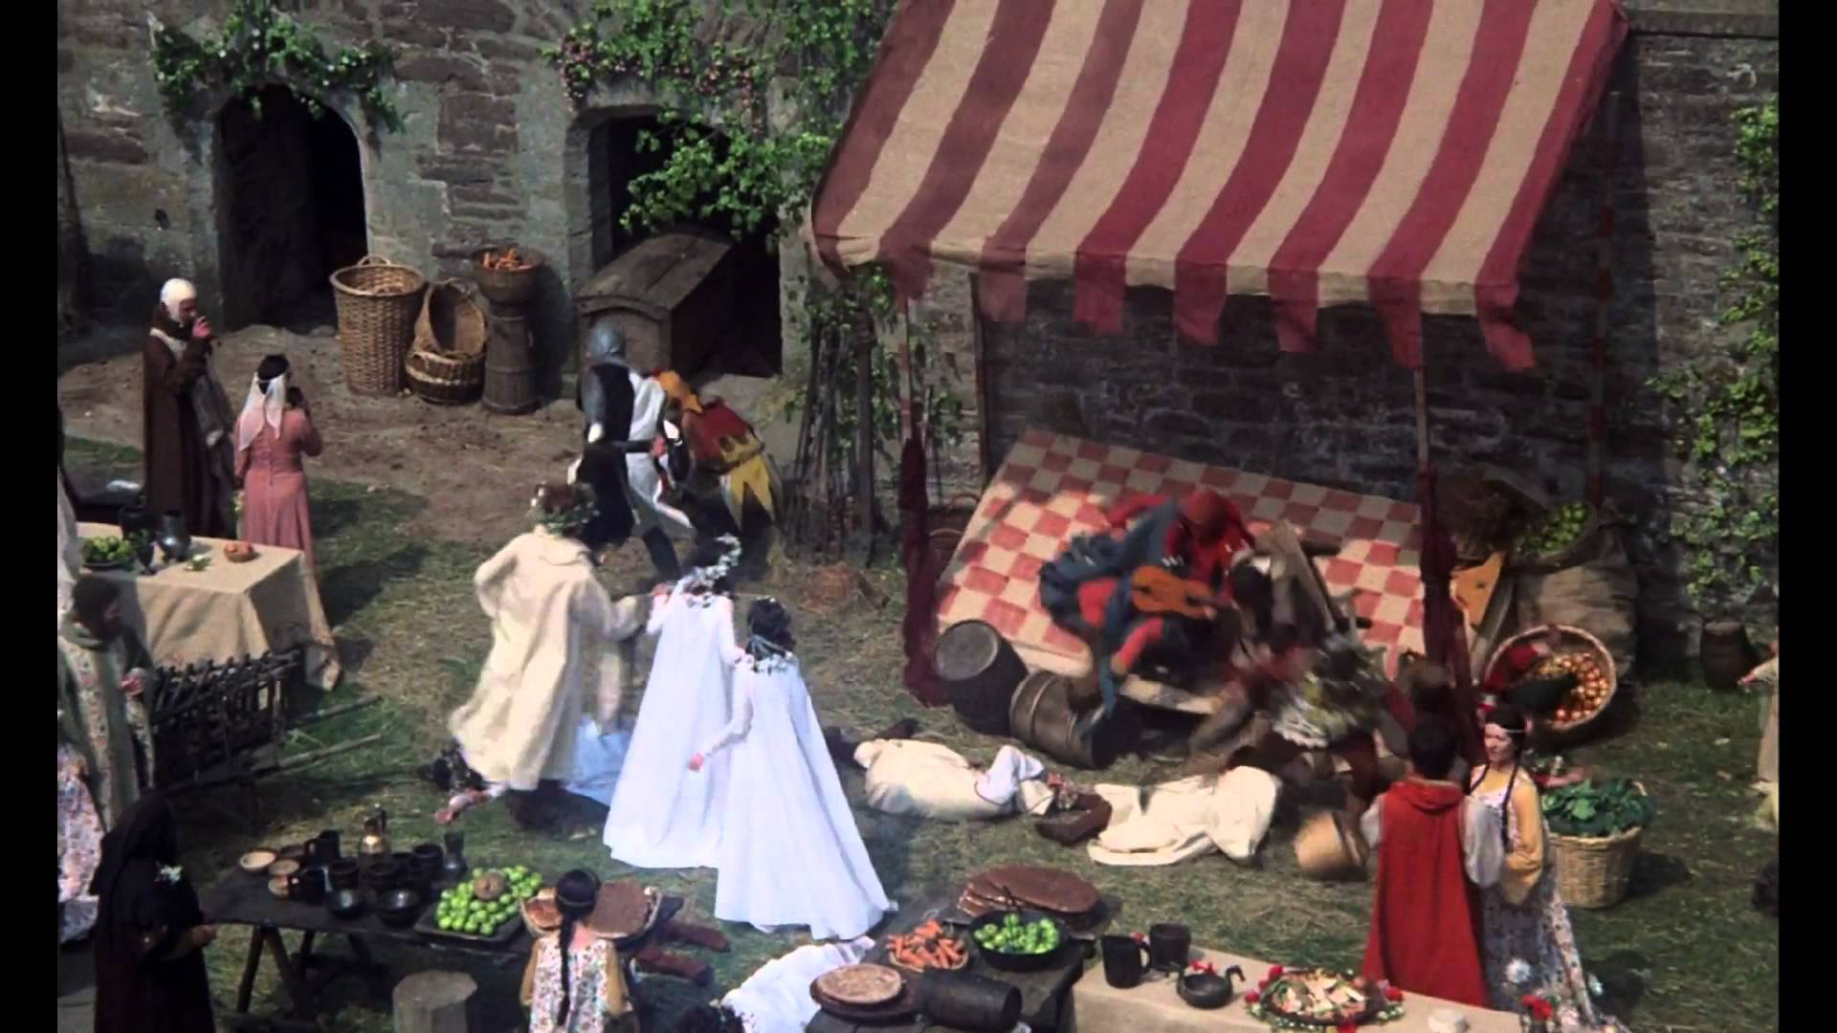

I like the colours used here, still has an old school filter look but some vibrancy with the reds. The curtain over the stage has the sort of wear and tear I like.